Should we resample the atlas to match the fMRI (BOLD) space, or resample the BOLD image to match the atlas space — and why?

What is “Resampling”?
Resampling adjusts one image’s voxel grid (its size, spacing, and orientation) so that it matches another image.
This ensures that corresponding voxels in both datasets represent the same physical locations in the brain.
In fMRI analysis, resampling allows voxel-wise comparison and region-based signal extraction across modalities (e.g., fMRI ↔ atlas).

Understanding “Space” in MRI/fMRI Analysis
In MRI and fMRI, space refers to the voxel grid and affine transformation that define how brain data are arranged in 3D.
Each image has its own:
- Image size: e.g., 256×256×150 (T1) vs 64×64×40 (BOLD)
- Voxel dimensions: e.g., 1×1×1 mm (T1) vs 3×3×3 mm (BOLD)
- Orientation and origin: scanner coordinate alignment
Because these differ, spatial alignment is essential before we can combine or compare data from different modalities.

fMRI (BOLD) vs. Structural / Atlas Images
Type | Typical Voxel Size | Purpose
Structural MRI (T1) | ~1 mm³ | High-resolution anatomical reference
Atlas | ~1 mm³ (usually T1 or template space) | Brain region labels (static)
fMRI (BOLD) | ~2–4 mm³ | Dynamic functional time-series data
The key difference is that fMRI has lower spatial resolution but temporal information, whereas the atlas is high-resolution but static.
What Happens if You Resample BOLD → Atlas ?
If you upsample the BOLD image to the finer atlas grid:
- The time-series become spatially blurred, reducing signal fidelity.
- We gain no new information — the BOLD signal remains intrinsically low-resolution.
- We inflate data size and computation time unnecessarily.
- In short, resampling the BOLD image distorts temporal accuracy and provides no analytical benefit.
Illustrative outcome:
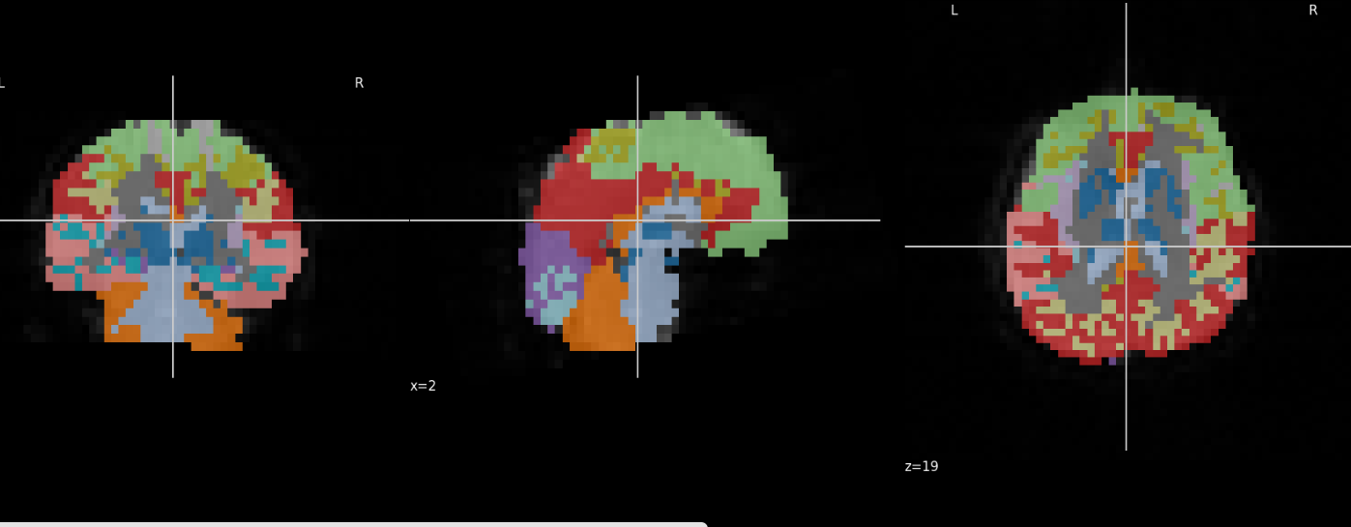
Correct Approach: Resample Atlas → BOLD Space
We always resample the atlas to match the BOLD resolution using nearest-neighbor interpolation: (The Python code )
from nilearn.image import resample_to_img
atlas_in_bold = resample_to_img(atlas_img, bold_img, interpolation='nearest')

Illustrative outcome: 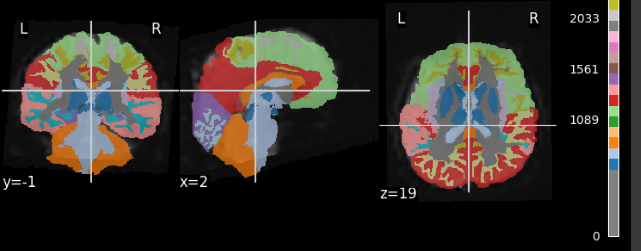

Summary :
We should resample the atlas to the BOLD space, because:
- The BOLD (fMRI) data contain dynamic time-series — resampling it would distort real signal values.
- The atlas contains static, discrete region labels — resampling those with nearest-neighbor interpolation is safe.
- The goal is to extract region-wise BOLD signals, so the atlas must match the fMRI voxel grid.
Operation | Recommended? | Reason
Atlas → BOLD space | Yes | Aligns labels to fMRI data .
BOLD → Atlas space | No | Blurs and distorts temporal signals.

Resampling the atlas to BOLD space ensures anatomical labels and functional data are precisely aligned while keeping the fMRI signal accurate and unaltered.

